**CONDITIONAL FORMATTING LAB**

1. Apply conditional formatting to highlight cells in the Sales column (D) with values greater than or equal to 150.

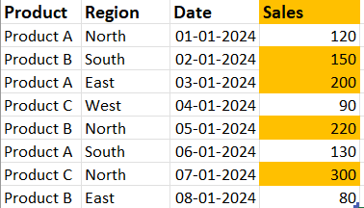

2. Apply conditional formatting to highlight the entire row for entries where the Product is "Product A".

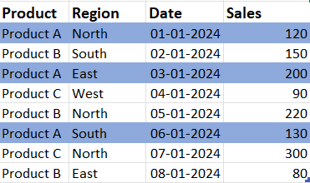

3. Apply conditional formatting to highlight cells in the Date column (C) that fall within January 2024.

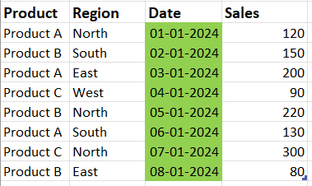

4. Apply conditional formatting to highlight the top 3 sales values in the Sales column (D).

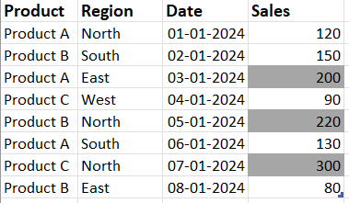

5. Apply conditional formatting to highlight sales for "Product B" in the "North" region.

